**DETECTION OF DISTRACTED DRIVER USING CONVOLUTIONAL NEURAL NETWORK**

To execute the project type the below command in the command prompt

python AbnormalBehaviour1.py --model resnet-34_kinetics.onnx --classes action_recognition_kinetics.txt

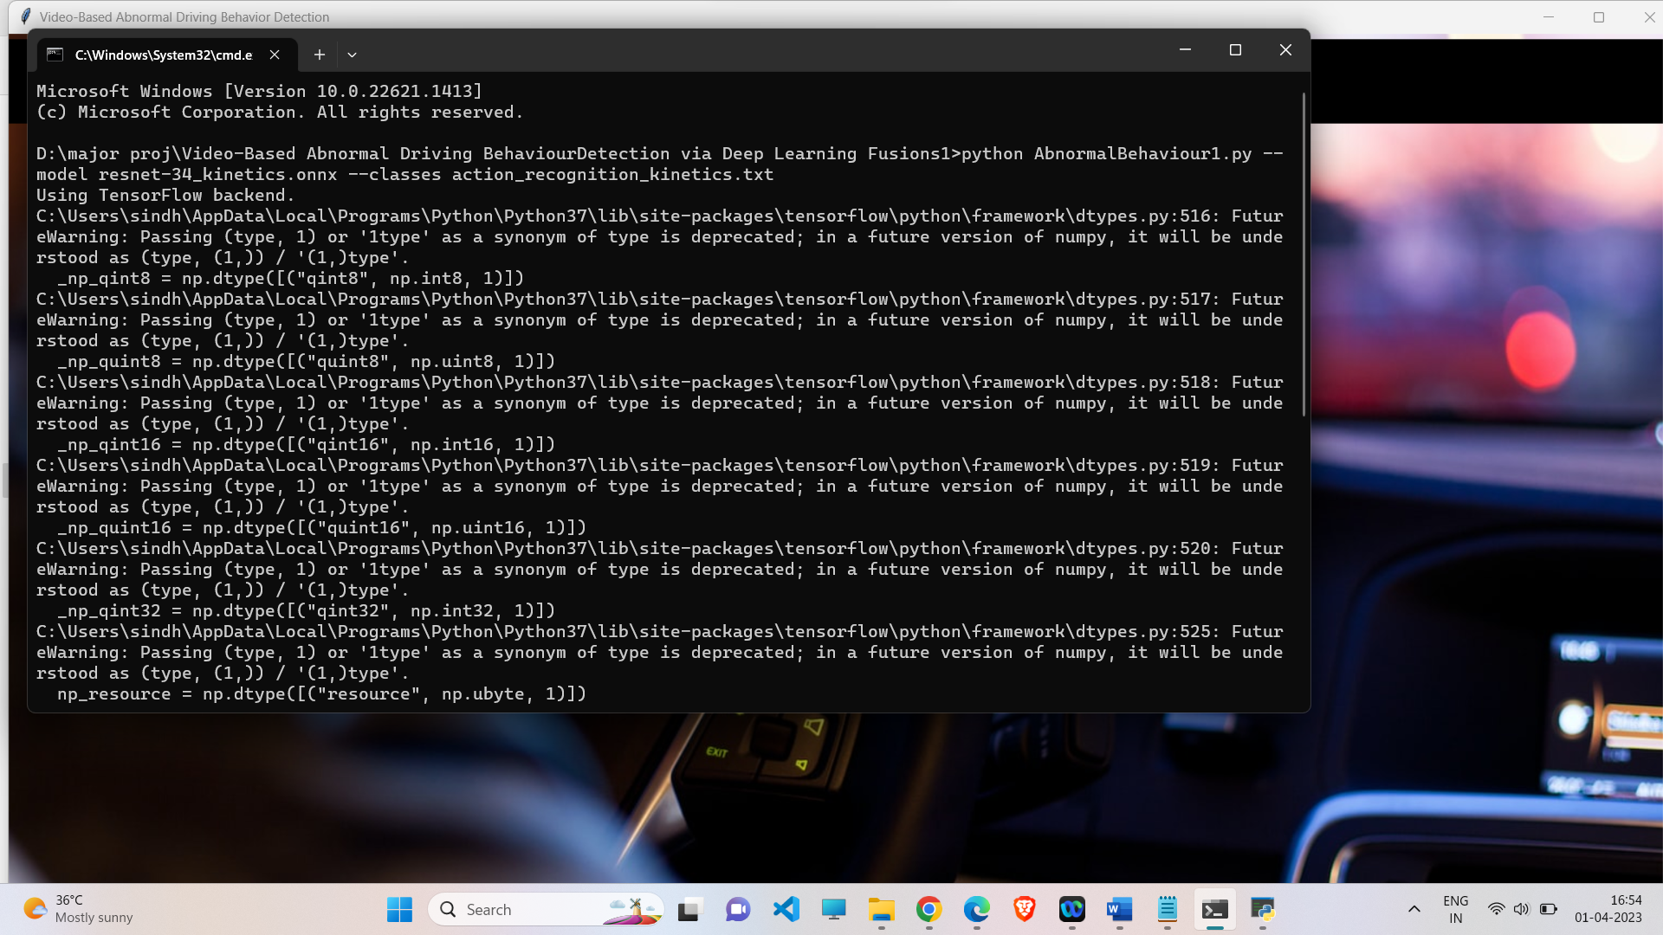

The below window opens

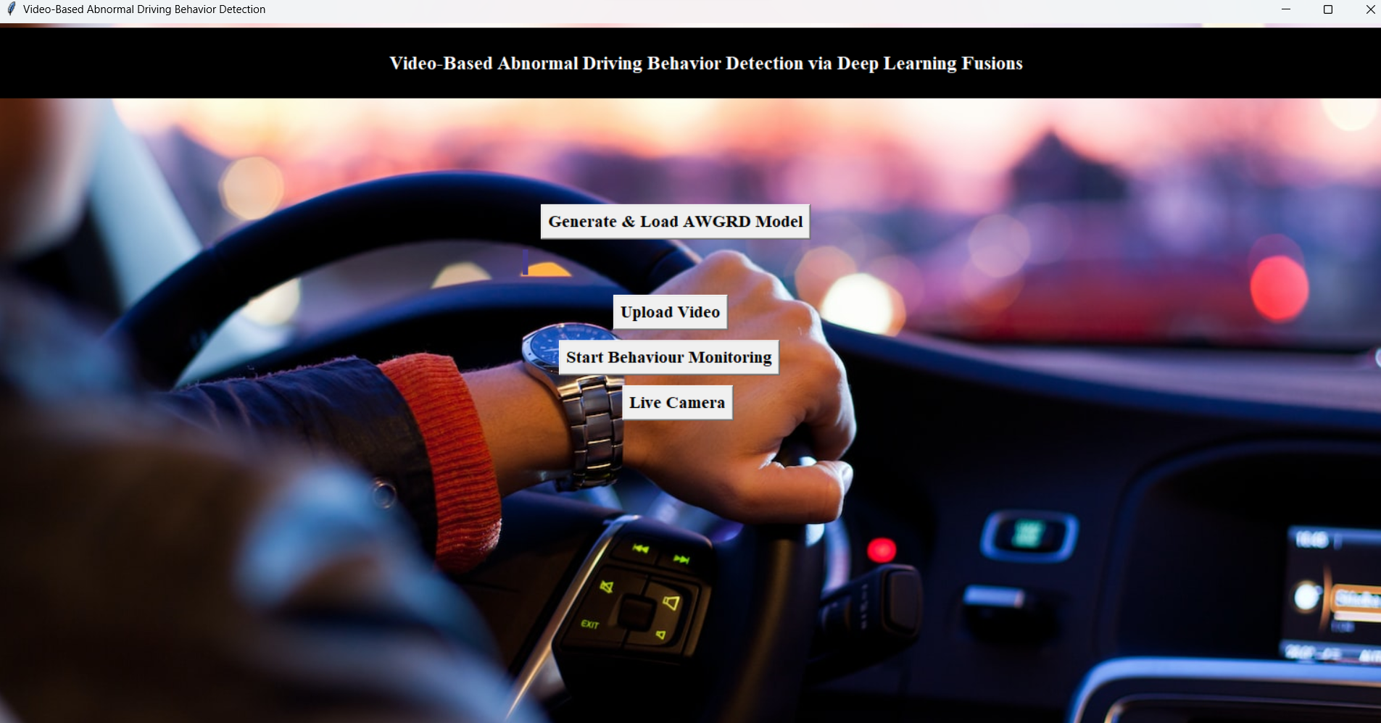

**To classify actions based on Uploaded Video**

First click on generate and load model to load the model.

Next upload any video having driver actions

Click on Start behaviour Monitoring

Then another window opens and the classified action is displayed on top left.

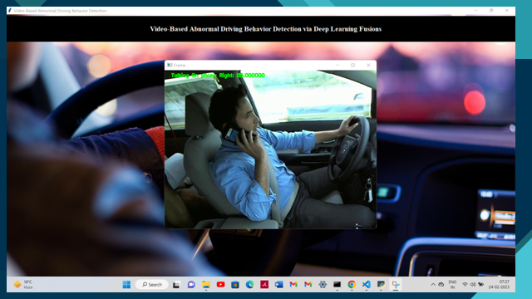

**To classify actions based on Live Video**

Click on Live Camera

Then perform actions. The classified action is displayed on top left.

